**CP70071E Deep Learning**

**Lesson 2 Workshop**

1. **Instruction:** To consolidate the knowledge learned through this lesson, you are tasked to implement perceptron binary classification using Microsoft Excel, and demonstrate that your implementation can solve the AND function approximation.

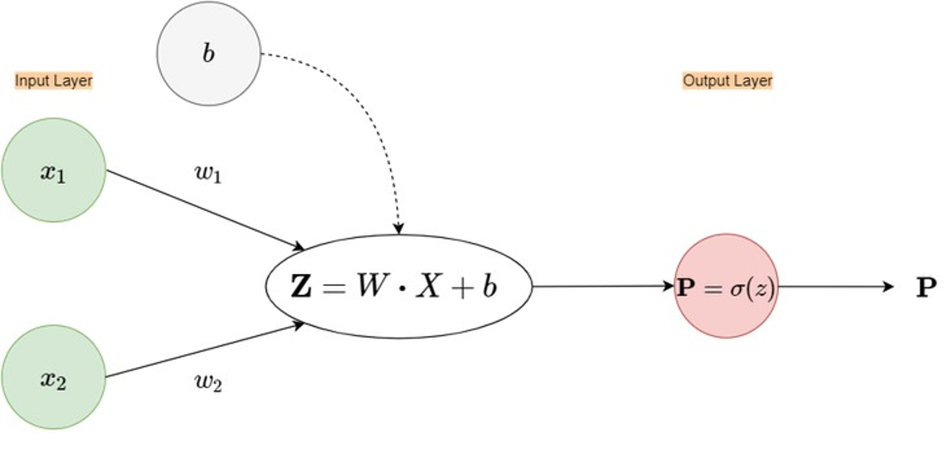

 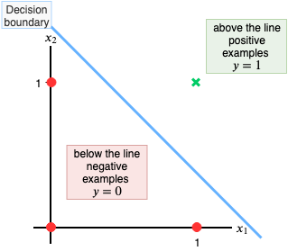

Figure 1

1. **Resource:** With assumption that you have access to Microsoft Excel, create a new template with the following setup. From there, you start implement the perceptron binary classification for the AND function approximation based on the formulas discussed in the lecture.

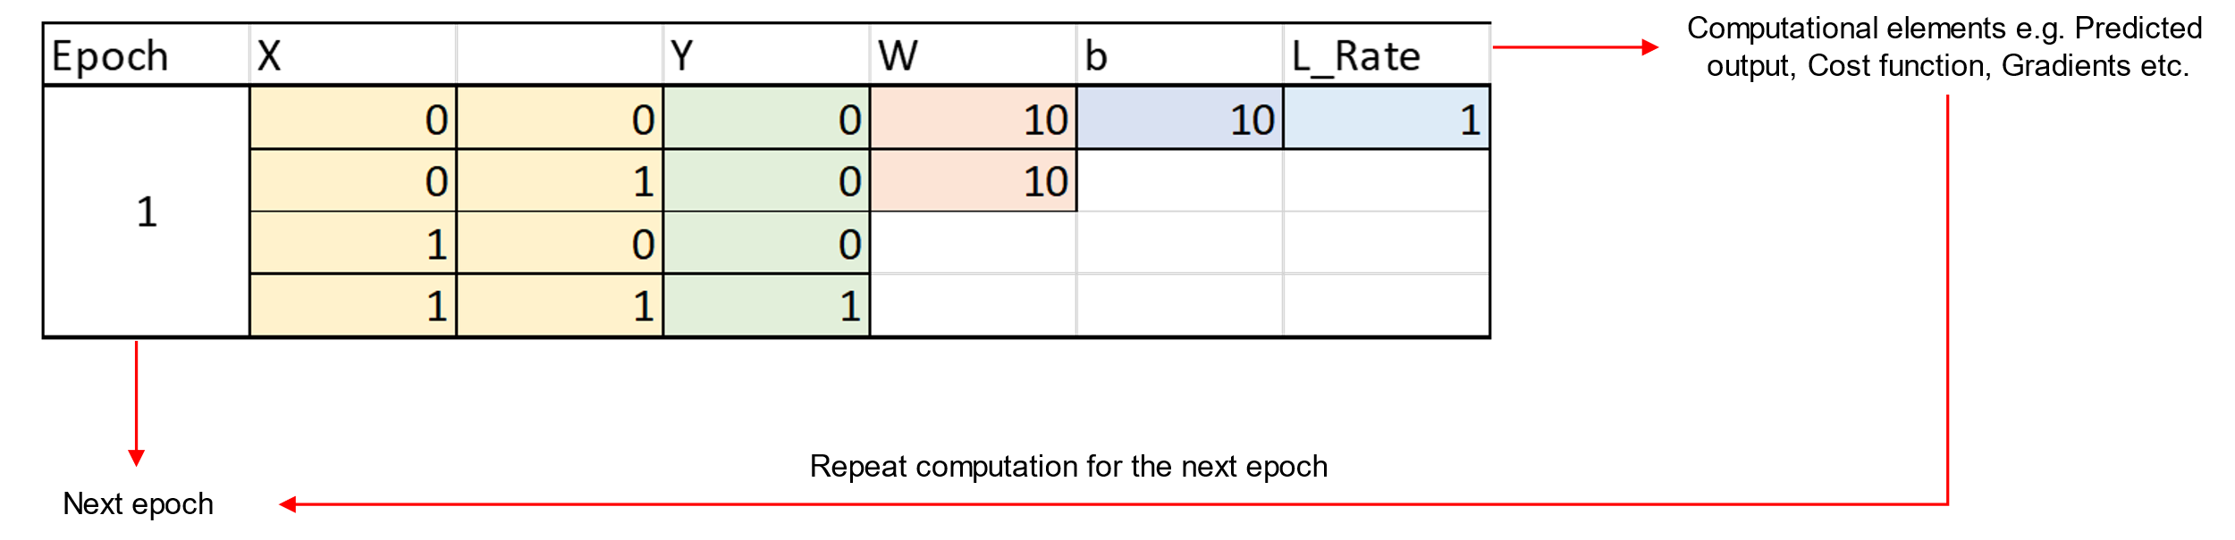

Figure 2

1. **Expected outcome:** You are required to plot the Cost function value at every epoch, up to 70 epochs. Your plot should be inline with the Figure 3.



Figure 3

1. Investigate if the Cost function can reach less than 0.09. If it is possible, by how many epoch the Cost function reaches less than 0.09?